
AI-Powered Legal Document Generator
Phase 01:
Brainstorming and Ideation

AI-generated template, not legal advice; have a lawyer review.

Table of Contents
1. Introduction 2
2. Problem Statement 2
3. Target Users and Personas 2
4. Idea Generation and Comparison 3
5. Proposed Solution and Value 3
6. Features: Must-have and Nice-to-have 4
7. Why Google Gemini, and the Risks 4

1. Introduction
This document records how the LegalEase idea was chosen. It describes the problem, the people who face it, the five ideas that were compared, the selected solution and its value, the feature list and the reasons for choosing Google Gemini, together with the main risks.

2. Problem Statement
Freelancers, small businesses and students often need simple legal documents such as freelance contracts, non-disclosure agreements (NDAs) and rental agreements. Hiring a lawyer for a first draft is slow and expensive, while free online templates are generic, hard to edit and often badly formatted. People end up copying documents from the internet and changing names by hand, which leads to missing clauses, wrong dates and unprofessional files.
- Cost: a lawyer-drafted first version of a simple contract is expensive for a small freelance project.
- Time: people need a draft in minutes, not days, before work starts or a tenant moves in.
- Quality: copied templates miss clauses, keep old names and dates, and look unprofessional.
- Editing: many free generators give text that cannot be edited or exported to Word and PDF.

3. Target Users and Personas
Table 1: User personas
Persona | Context | Pain point | How LegalEase helps
Priya, freelance UI designer (26) | Works with 3-5 new clients a month and needs a quick freelance contract or NDA before starting work. | Lawyer fees are high for small projects; templates online miss her payment and deadline terms. | Types the client name and her terms, downloads a branded PDF in two minutes and sends it for review.
Rajesh, small landlord (48) | Rents out two flats in Chennai and prepares an 11-month rental agreement for every new tenant. | Edits an old Word file each time; rent, deposit and dates are often left unchanged by mistake. | Enters the address, rent and deposit as terms; the lease clauses are filled in and he edits the rest.
Karthik, startup founder (31) | Hires his first employees and interns and needs offer letters and employment contracts. | Has no in-house legal team and little time; wants consistent documents with the company logo. | Uploads the company logo once and generates employment contracts with probation and notice terms.

4. Idea Generation and Comparison
Five AI project ideas in the legal domain were brainstormed and scored on user impact, build complexity for a 4-week internship and how well generative AI fits the task.
Table 2: Comparison of five project ideas
Idea | Users | Impact | Complexity | AI fit | Decision
1. LegalEase: AI legal document generator | Freelancers, small businesses, students | High | Medium | High (Gemini + templates) | Selected
2. Contract clause risk checker | Lawyers, legal teams | Medium | High | Medium (needs legal data) | Rejected: needs expert-labelled data
3. Legal Q&A chatbot | General public | High | Medium | Low (risk of advice) | Rejected: high risk of wrong legal advice
4. Court case summariser | Law students | Medium | High | Medium | Rejected: long PDFs, heavy processing
5. E-signature workflow tool | Businesses | Medium | High | Low (little AI) | Rejected: little AI value, many existing tools

Idea 1 was selected because it has a clear user, a realistic scope for four weeks, strong value from generative AI (drafting formal text) and a safe design: the output is a template that the user edits and a lawyer reviews, not legal advice.

5. Proposed Solution and Value
LegalEase is a web application that drafts a structured legal document from four simple inputs: document type, parties, terms (separated by semicolons) and effective date. A FastAPI backend builds a careful prompt and asks Google Gemini to write the draft. The Streamlit frontend shows a styled preview, lets the user edit the text, and exports the edited version as TXT, DOCX or PDF with a logo, numbered clauses, a terms table and a disclaimer footer. Without an API key the app runs in Demo mode using deterministic offline templates, and if Gemini fails it falls back to the same templates with a clear message.
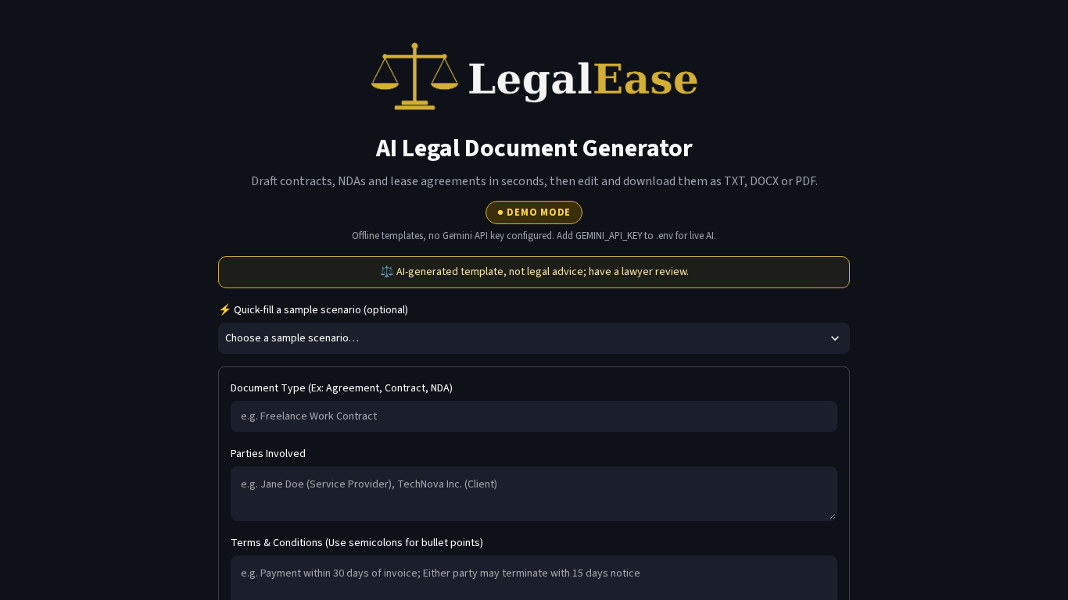
Figure 1: The selected idea as built: LegalEase home page in Demo mode
- Speed: a structured draft in seconds (Demo mode answered in under 1 second in our tests).
- Control: the user edits the text and downloads exactly the edited version.
- Professional output: logo, numbered clauses, terms table, page numbers and disclaimer in every file.
- Always available: works without an API key (Demo mode) and falls back safely when Gemini fails.

6. Features: Must-have and Nice-to-have
Table 3: Feature priorities
Must-have (built) | Nice-to-have (built)
Input form: document type, parties, terms (semicolons) and effective date | Company logo upload for branded exports
AI generation through POST /generate with a structured legal prompt | Quick-fill sample scenarios
Demo mode without an API key and automatic fallback when Gemini fails | Mode badge from GET /health (Demo, Live Gemini, Backend offline)
Styled, scrollable HTML preview | Mobile-friendly layout
Edit the document, then download the edited version as TXT, DOCX and PDF
Input validation with friendly messages; disclaimer in the UI and in every export

Future ideas (not in this version): User accounts with saved document history (database); clause library and optional clauses selected with checkboxes; indian regional languages (tamil, hindi) with suitable pdf fonts; e-signature integration and version comparison (track changes).

7. Why Google Gemini, and the Risks
- Quality: current Gemini models write long, well-structured formal English and follow format rules.
- Current SDK: the google-genai Python SDK gives one client for the Gemini API with timeouts and typed errors.
- Free tier: Gemini has a free tier through Google AI Studio, suitable for an internship prototype.
- Flexibility: the model ID (default gemini-3.8-flash) is set in .env, so retired models are easy to replace.
Table 4: Main risks of using generative AI
Risk | Mitigation in LegalEase
No API key or quota exhausted | Demo mode and automatic fallback to offline templates
AI writes wrong or incomplete legal text | Structured prompt, output validation, disclaimer, lawyer review
Model retired or renamed | GEMINI_MODEL in .env; default gemini-3.8-flash
Prompt injection through user text | User text wrapped in <<< >>> delimiters; HTML escaped in preview
Privacy of client details | No database; nothing is stored after the session ends

